**Assignment/Project Day3. By Prasanna Sawant.**

PROJECT1.

Windows Instance- IPv4 Public IP - 18.222.226.141

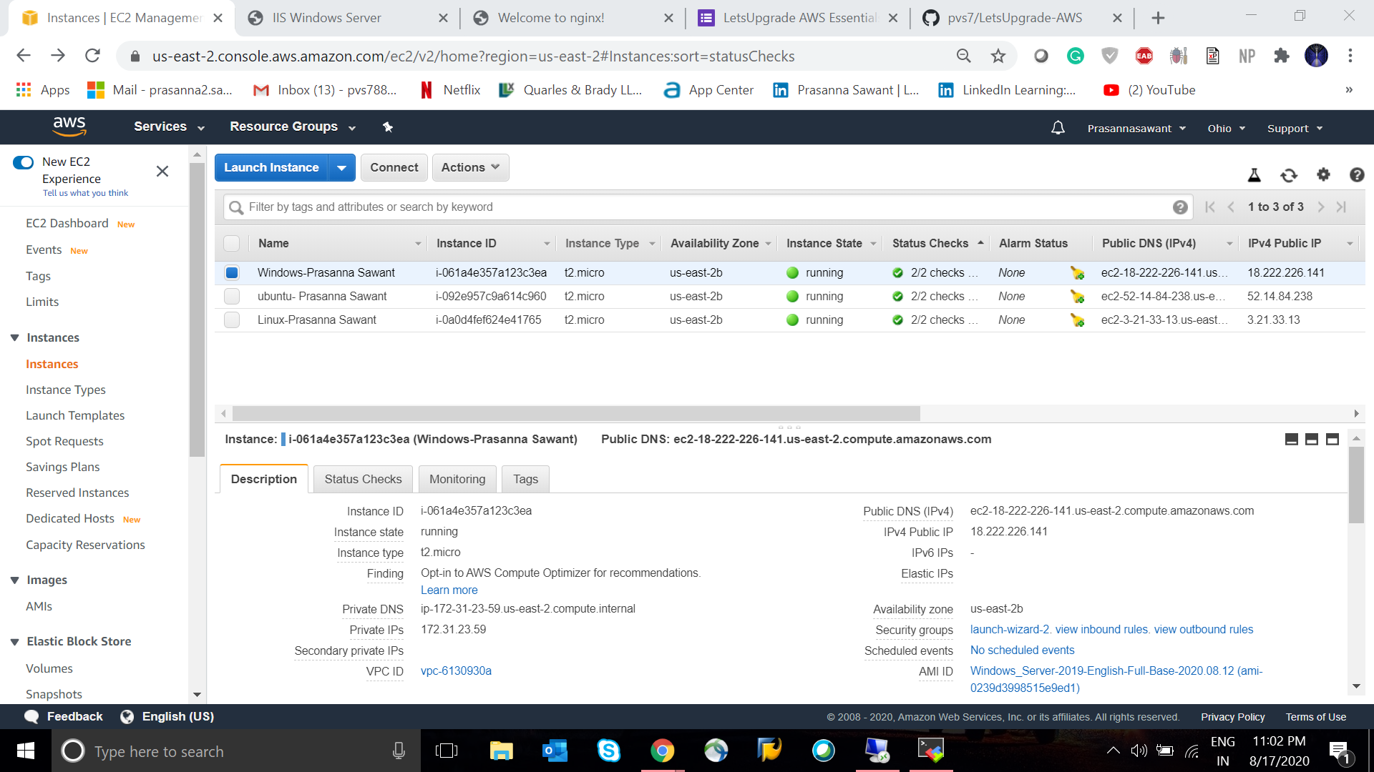  
  
Below are the results for Screenshot for Internet Information Services.

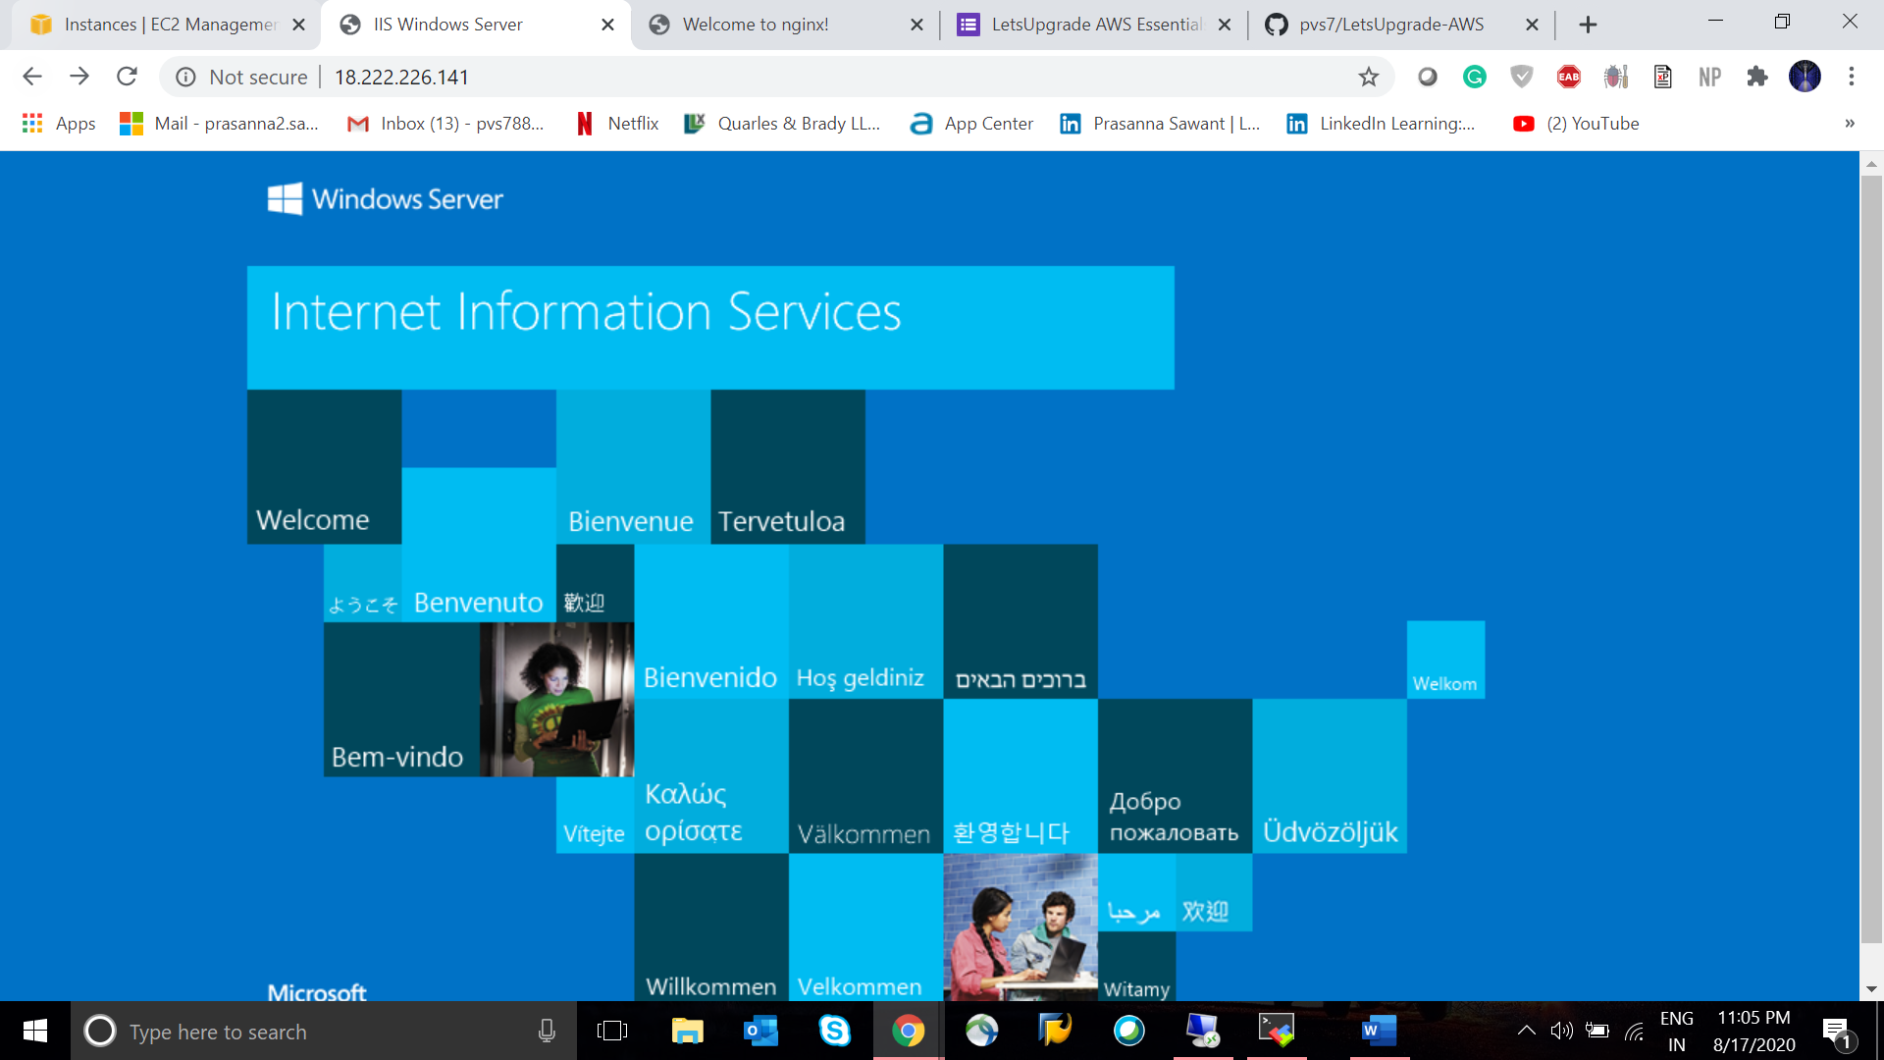

PROJECT 2.

Linux Instance- IPv4 Public IP - 52.14.84.238

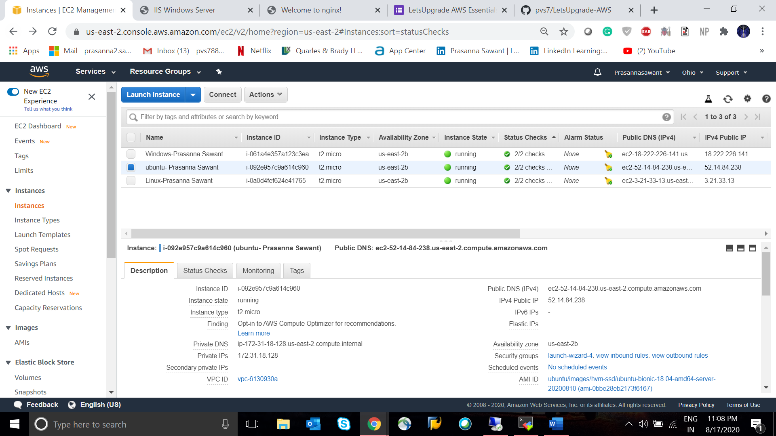

Below are the results for Screenshot for Welcome to ngnix Web page.

